Adding third party services such as Stream Sets (ETL tool) into Cloudera Manager

**Configuring third party service Stream sets (ETL tool) with Cloudera:**

* Login to the master machine
* switch to root user with command sudo su –
* Go to StreamSets website where you will find the packages and tarballs for StreamSets Data Collector.

<https://archives.streamsets.com/index.html>

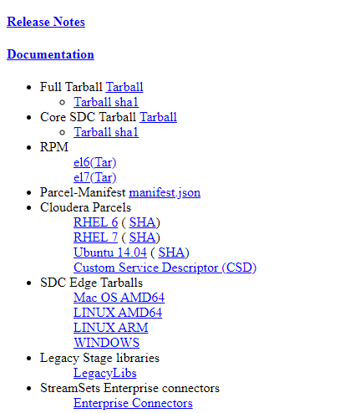

* Copy link of the RHEL 7(SHA) from Cloudera parcels tab.
* Go to path /opt/cloudera/parcel-repo/
* Install the Stream Sets Data Collector using below command:

wget https://archives.streamsets.com/datacollector/3.17.0/parcel/activation/STREAMSETS_DATACOLLECTOR-3.17.0-el7.parcel

wget https://archives.streamsets.com/datacollector/3.17.0/parcel/activation/STREAMSETS_DATACOLLECTOR-3.17.0-el7.parcel.sha

* Change permissions of the file to cloudera-scm by executing below command

sudo chown cloudera-scm:cloudera-scm /opt/cloudera/parcel-repo/ STREAMSETS_DATACOLLECTOR*

**Login to Cloudera Manager**

* Login to Cloudera Manager using ip address and port 7180

Eg: <http://3.235.181.239:7180/>

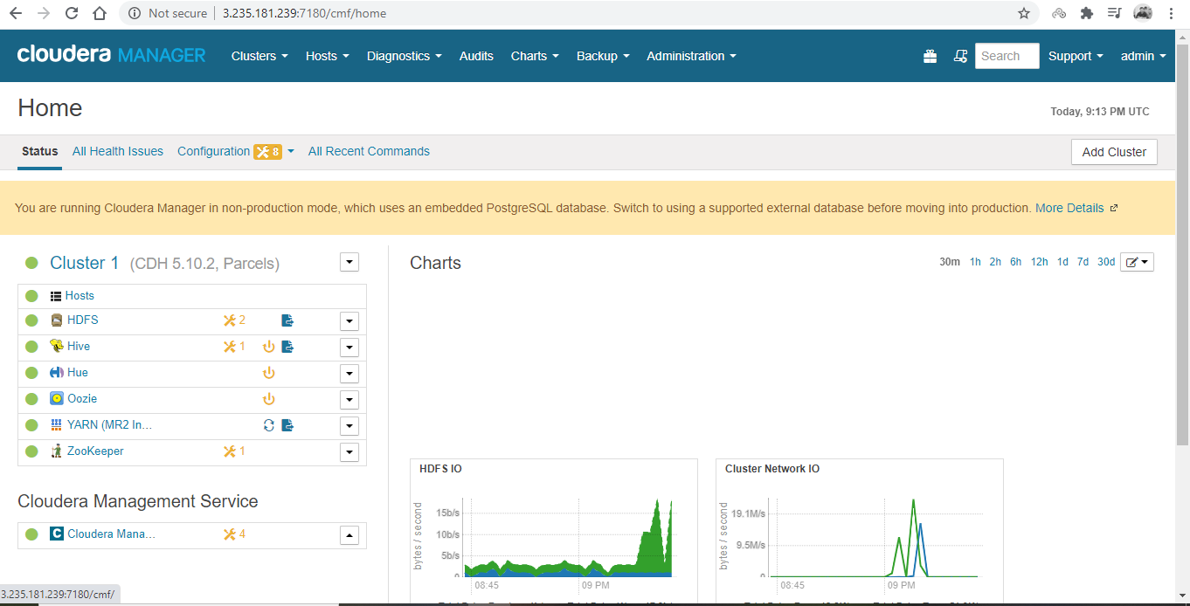

**Click on the drop box 🡪 Add service 🡪 Select Streamsets**